Month Close Process : Inventory 🡪 OPM Financials 🡪 View 🡪 Request 🡪 Submit a New Request 🡪 OK

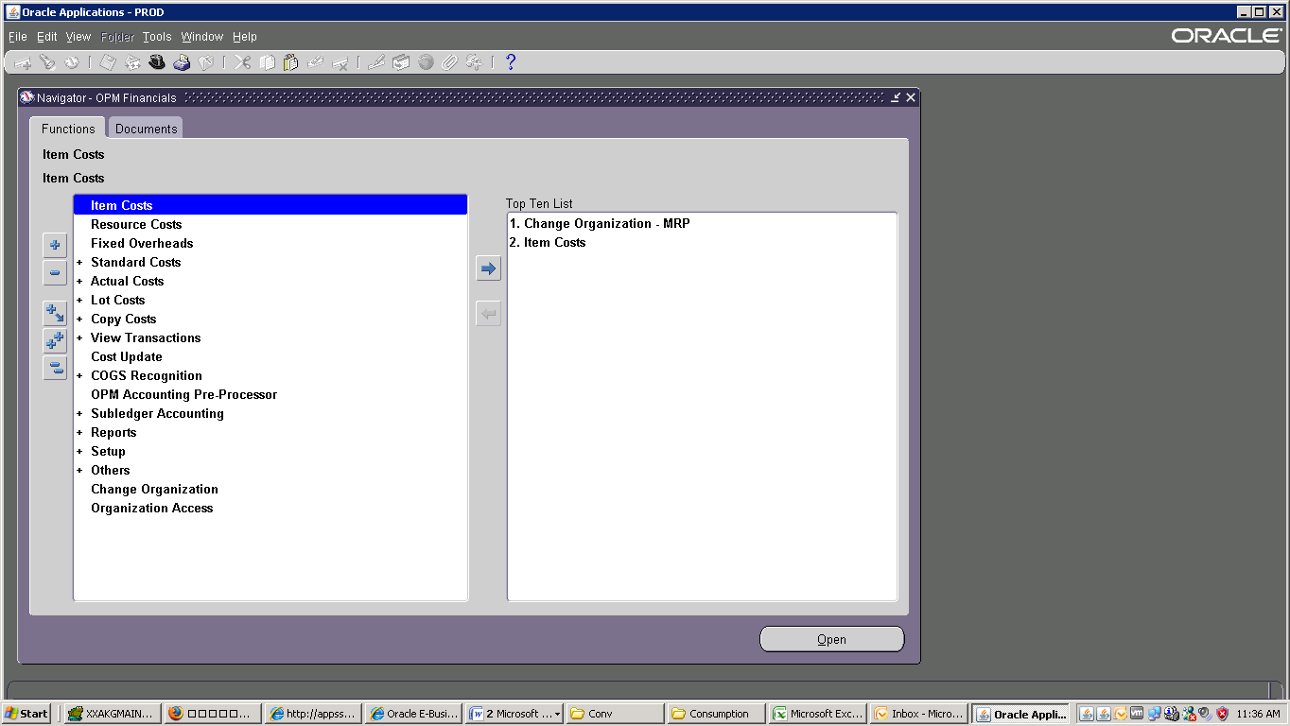

🡪 Find : gmf 🡪 GMF Period Close Process for Process Organizations 🡪 Parameters

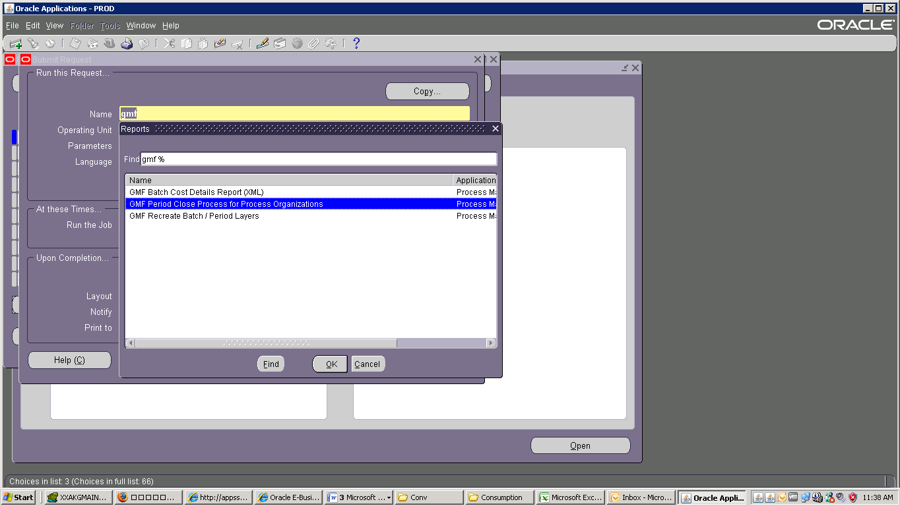

Select Parameters : Legal Entry : Cement Division🡪 Fiscal Year 2016🡪 Fiscal Period : 3 Final Close: No

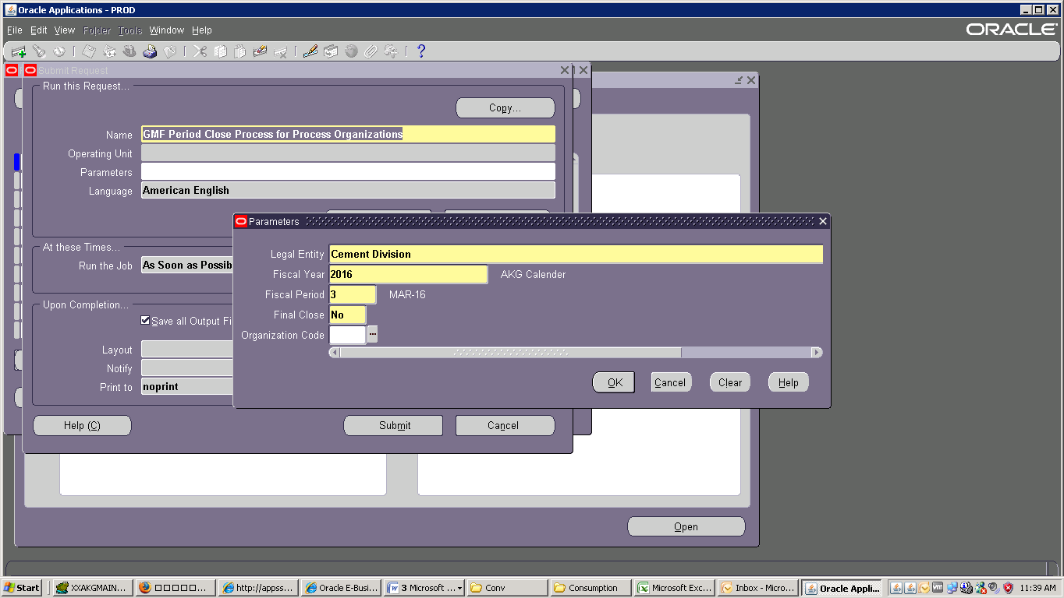

Than OK 🡪

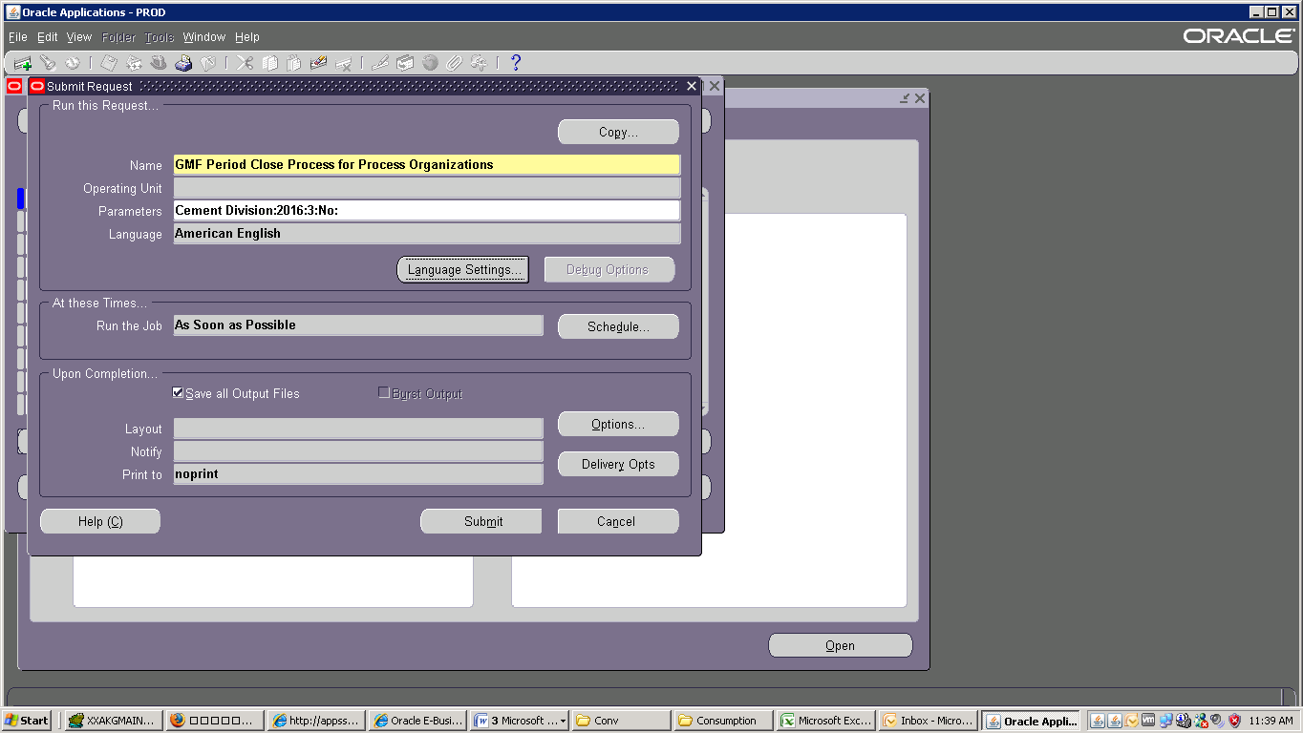

Click Submit than Refresh Data:

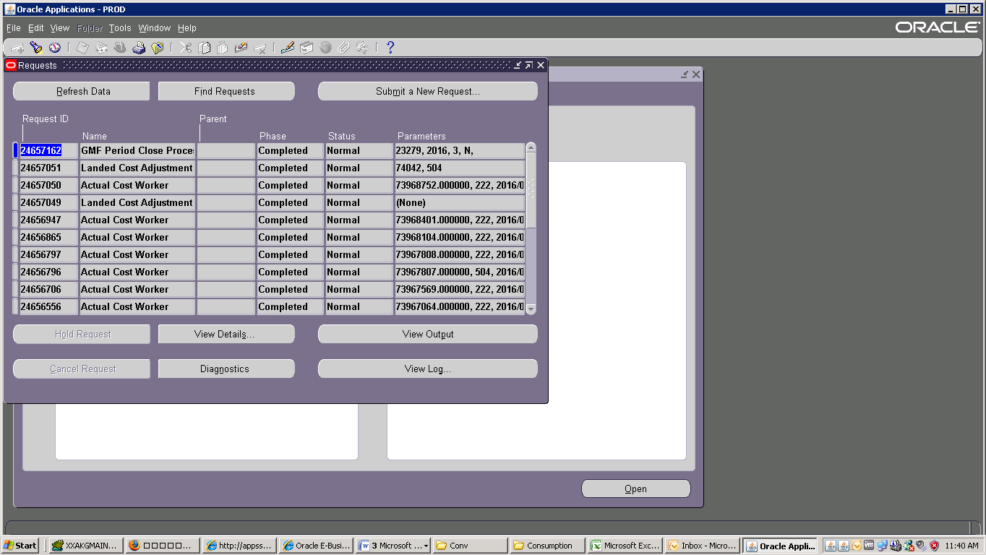

Submit a New Request 🡪 OK 🡪 View 🡪 Request 🡪 gmf find 🡪 GMF Recreate Batch / Period Layers

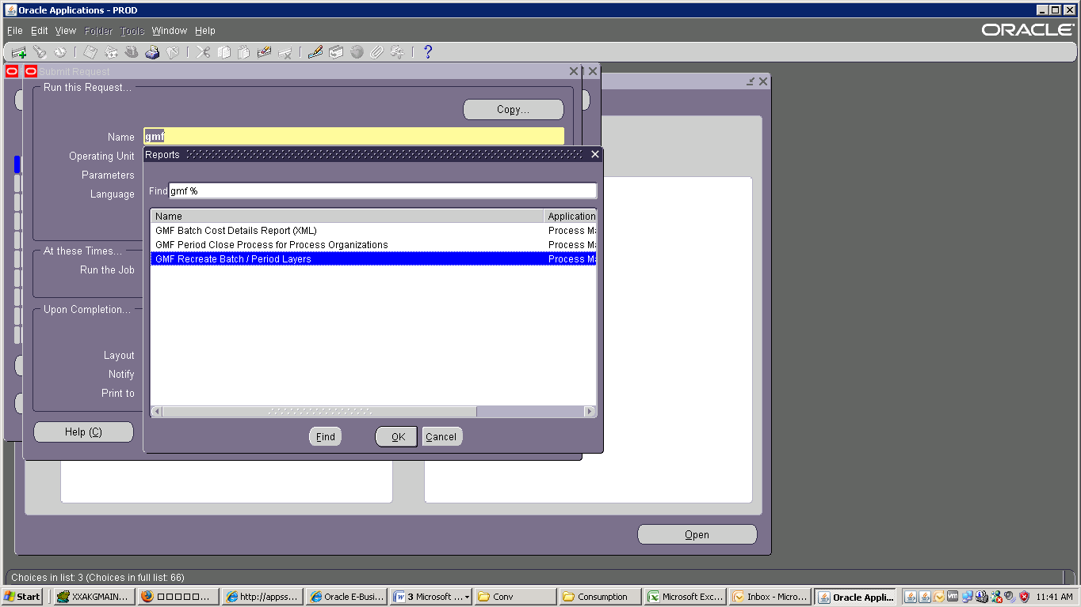

Parameters : Legal Entry : Cement Division🡪 Cost Calendar AKG 2016🡪 Period : 3 🡪Cost Type : PMAC

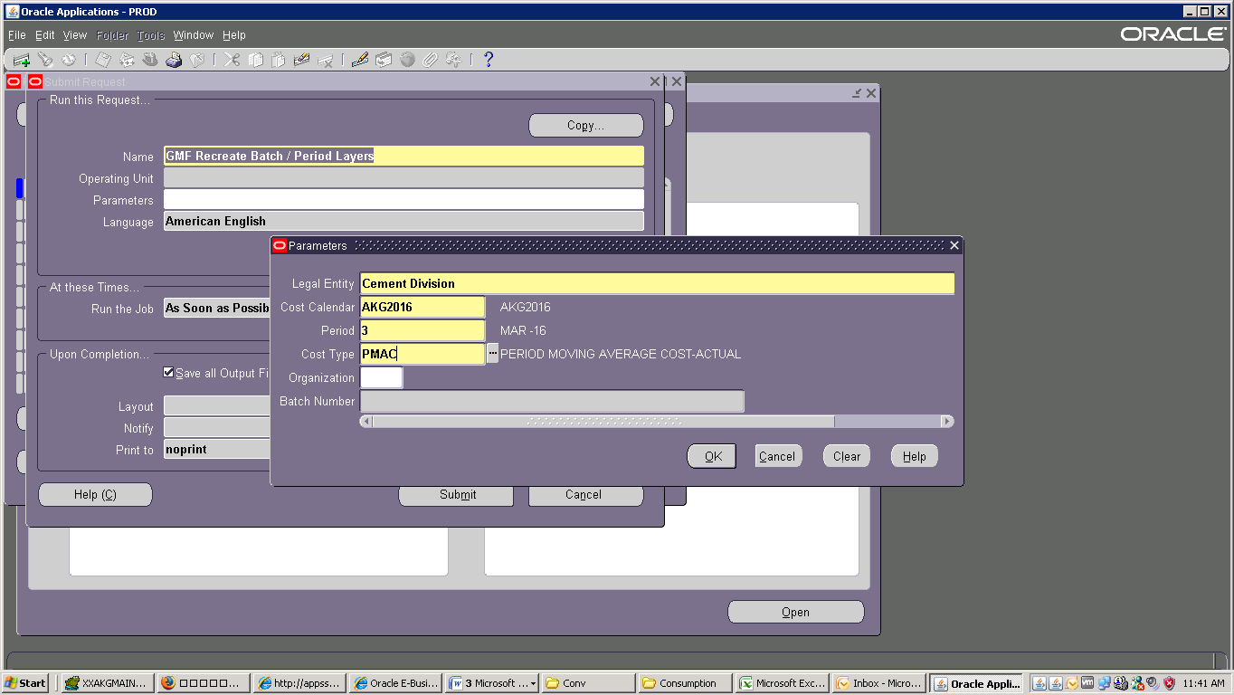

Than Submit

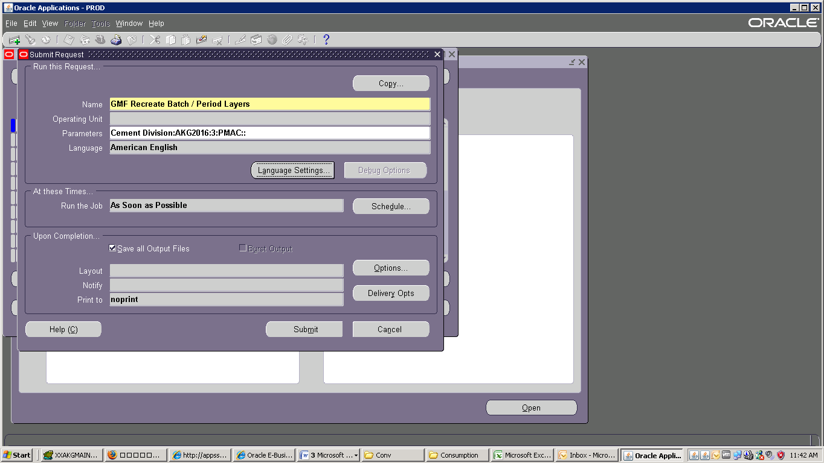

Click Submit than Refresh Data:

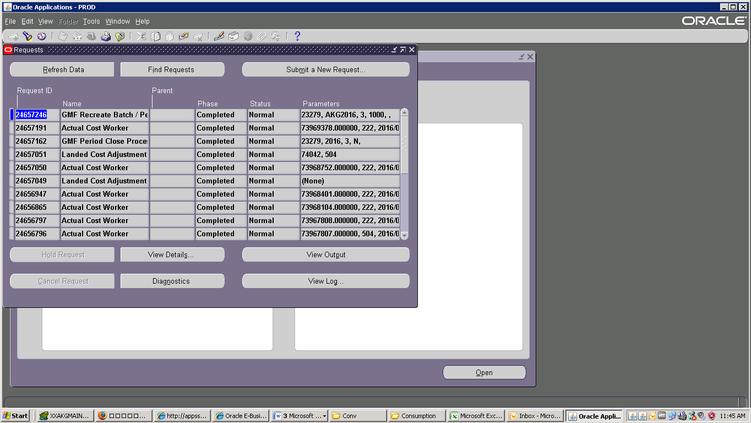

View 🡪 Request 🡪 Submit a New Request 🡪 OK Find : lan🡪 Landed Cost Adjustments Import Process

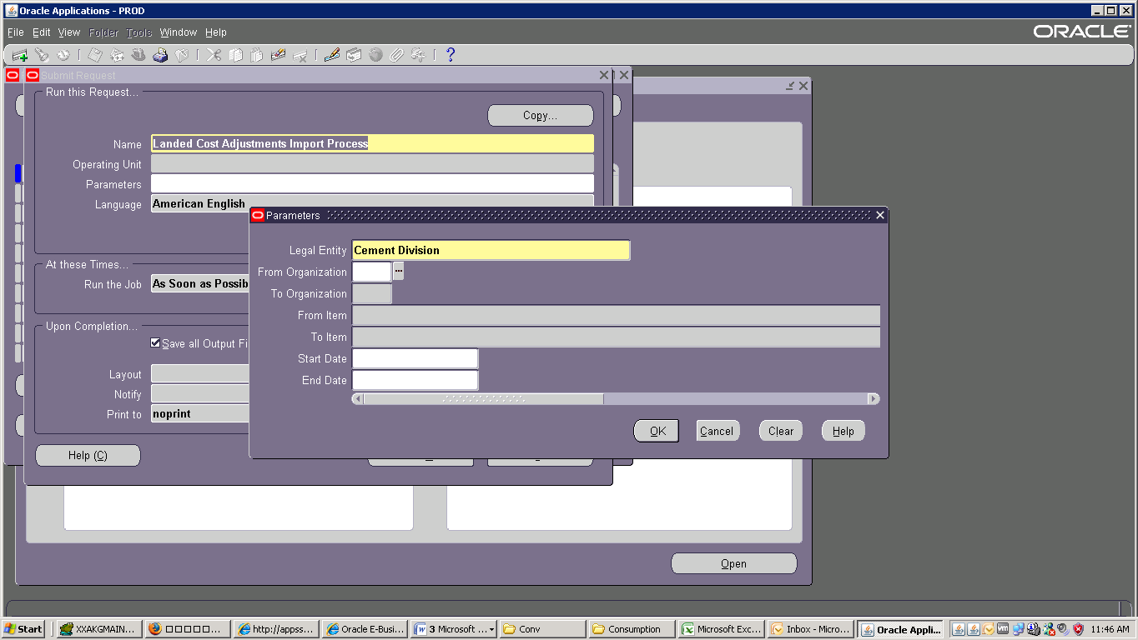

Select : Cement Division 🡪 No

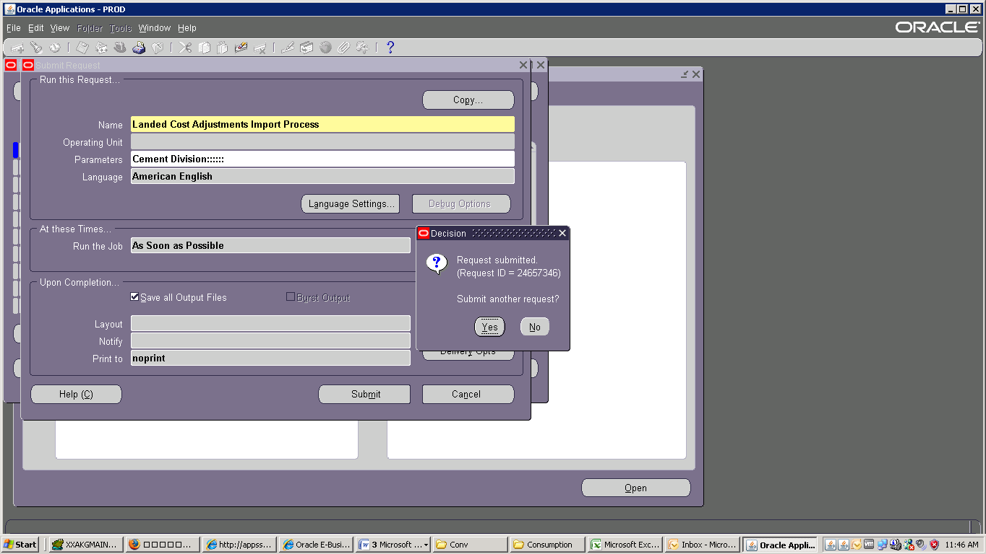

Click Submit than Refresh Data:

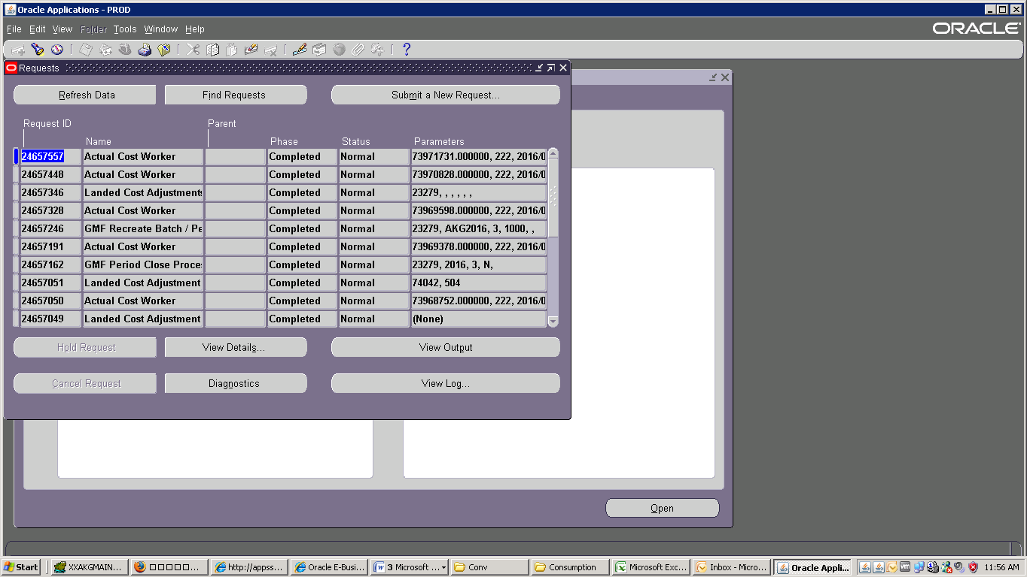

Select : Actual Cost 🡪Process Actual Cost

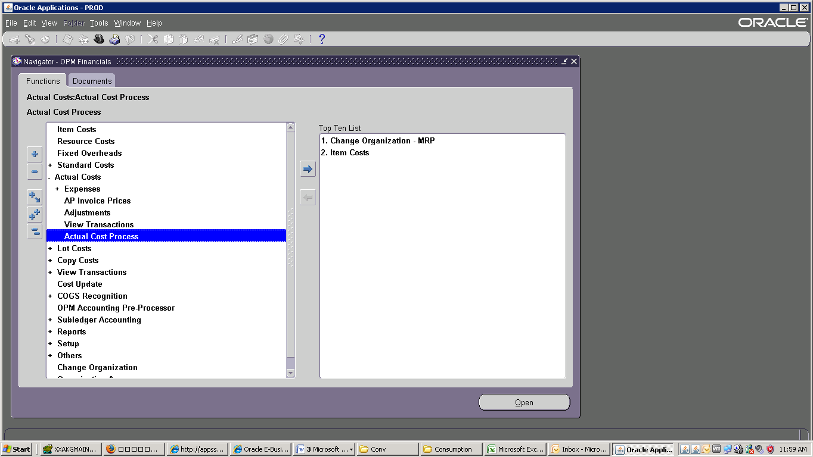

Parameter : Legal Entry : Cement Division🡪Fiscal Year 2016→ Fiscal Period : 3 Final Close: No

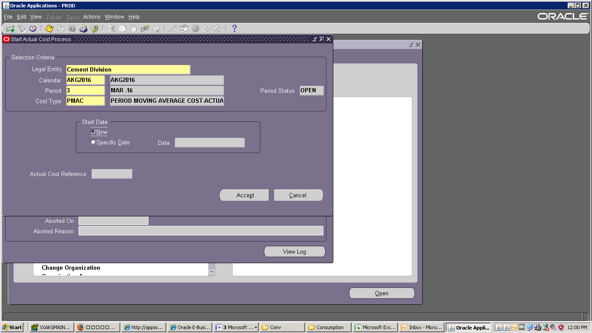

Parameters : Legal Entry : Cement Division🡪 Calendar : AKG2016🡪 Period : 3 🡪Cost Type : PMAC

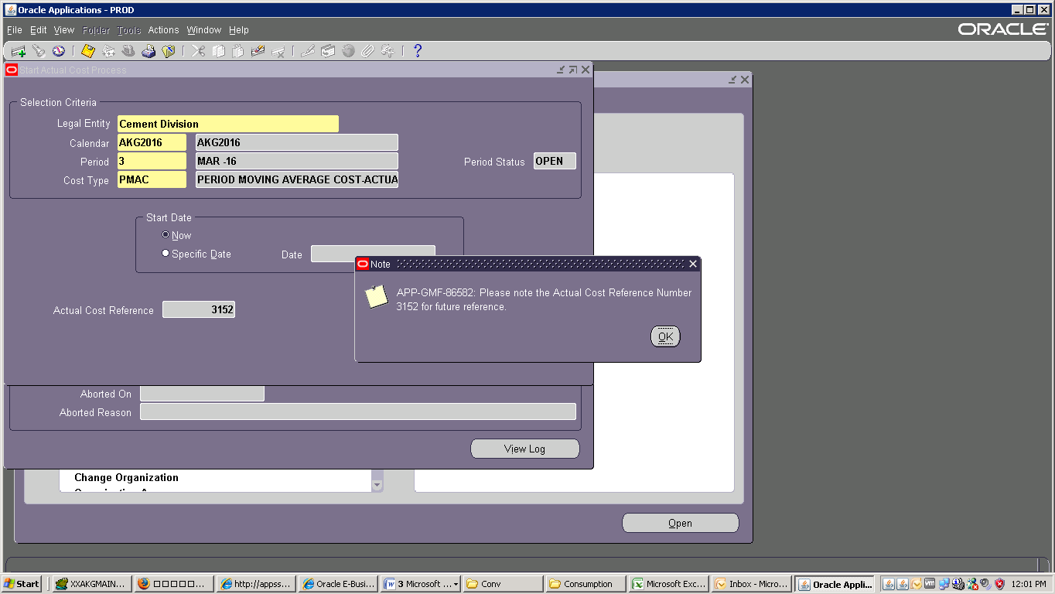

Than OK

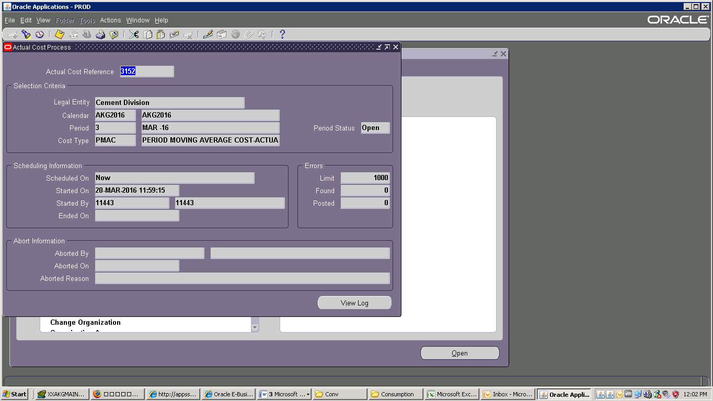

Click Submit than Refresh Data:

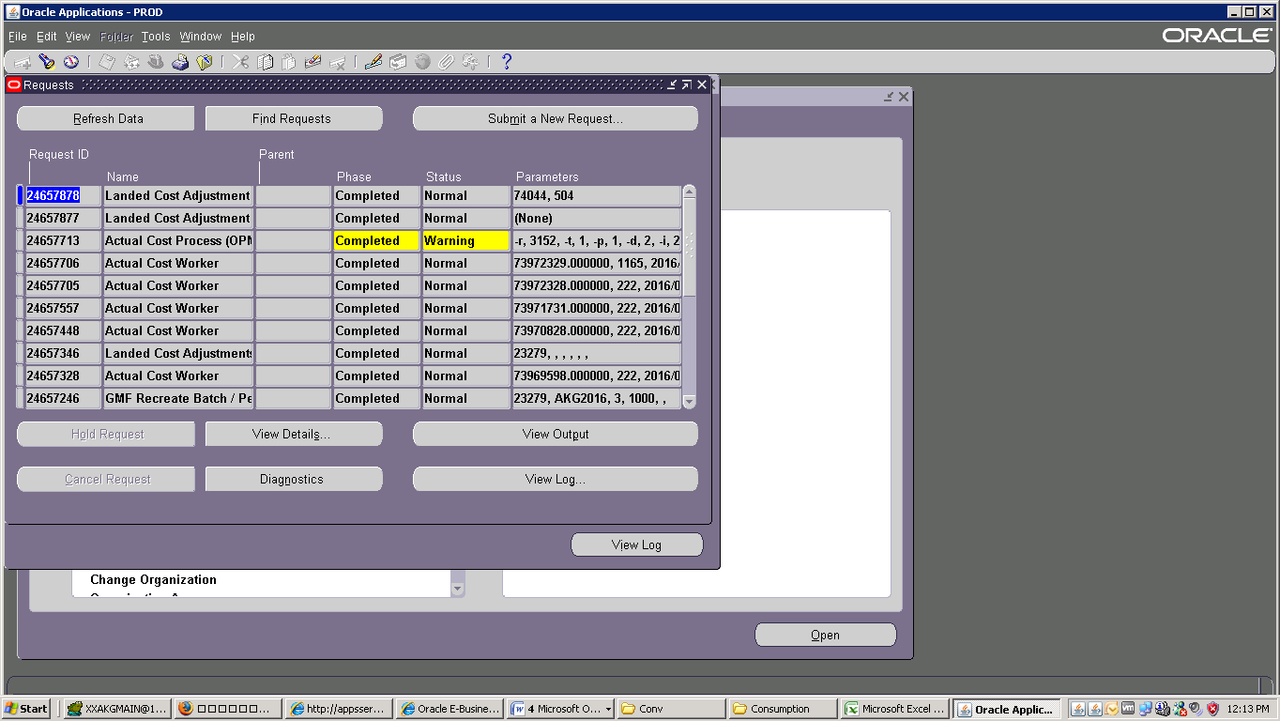

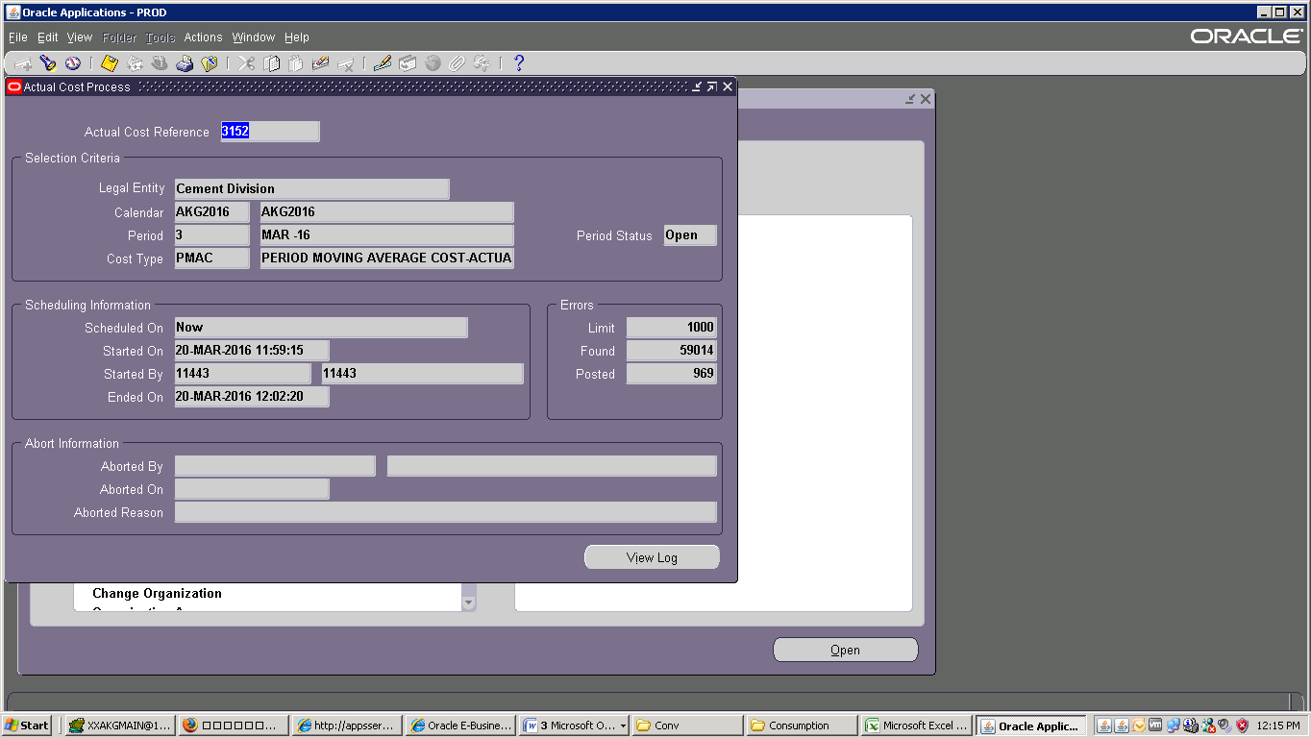

Cost Update :

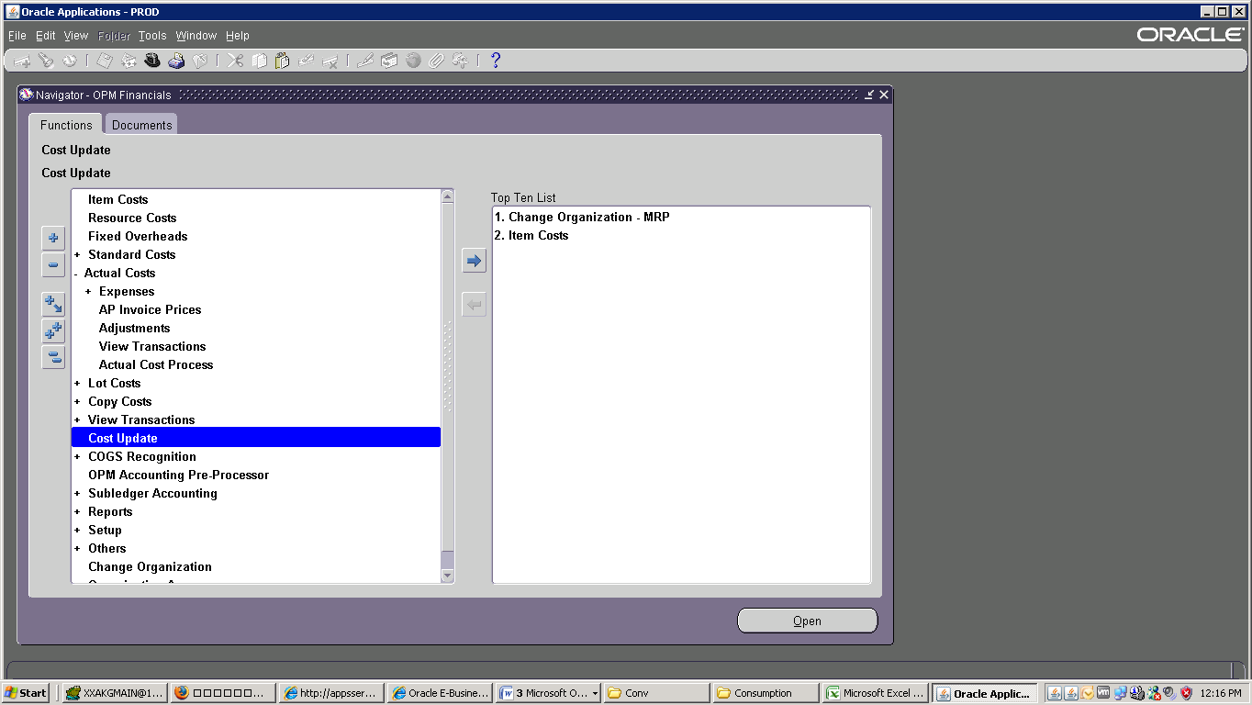

Parameters : Legal Entry : Cement Division🡪 Calendar : AKG 2016🡪 Period : 3 🡪Cost Type : PMAC

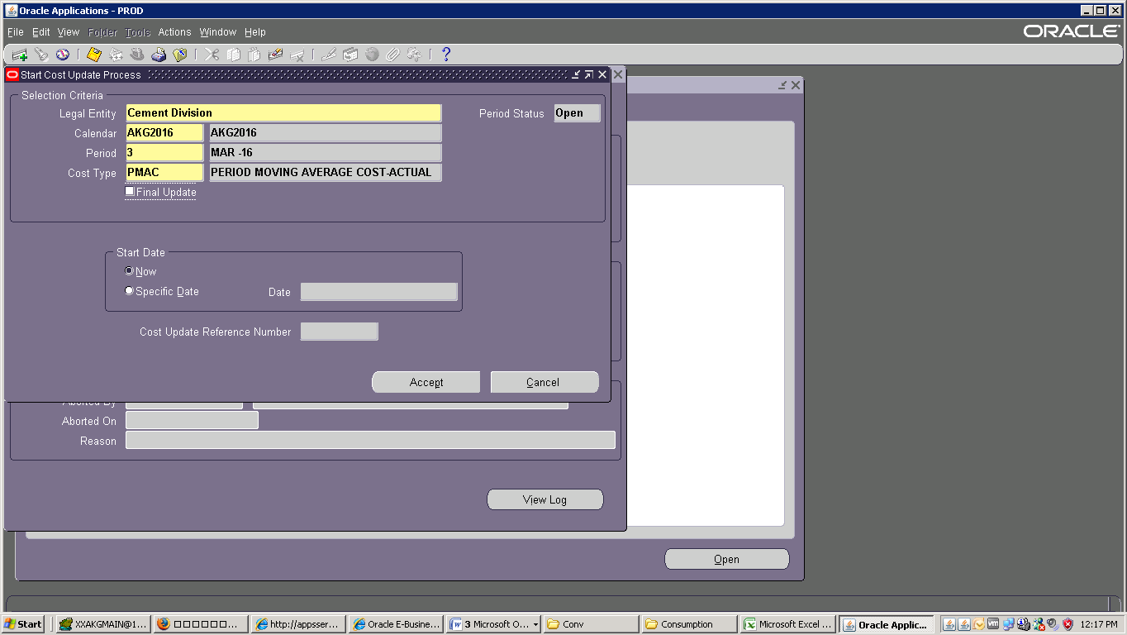

Than OK 🡪 Click Submit than Refresh Data:

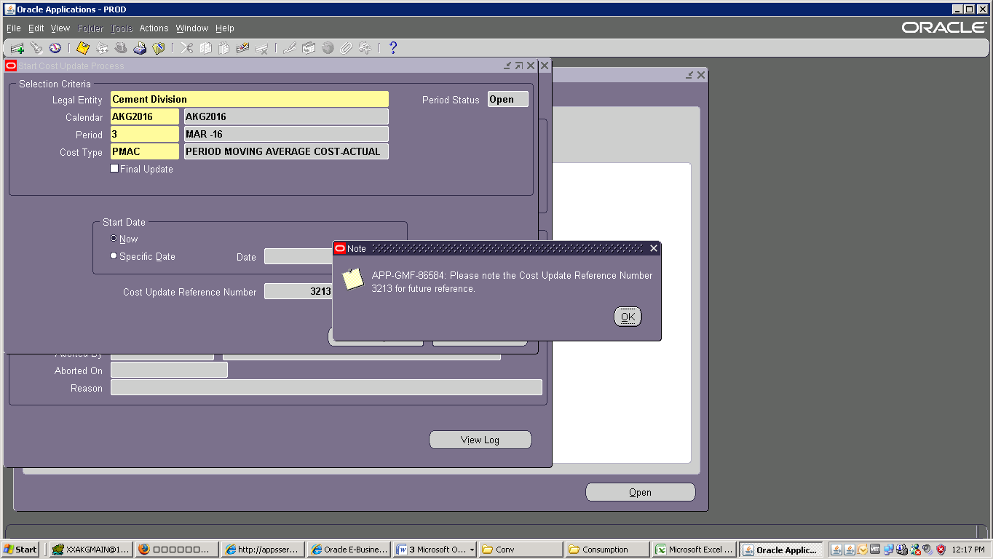

Click Submit than Refresh Data:

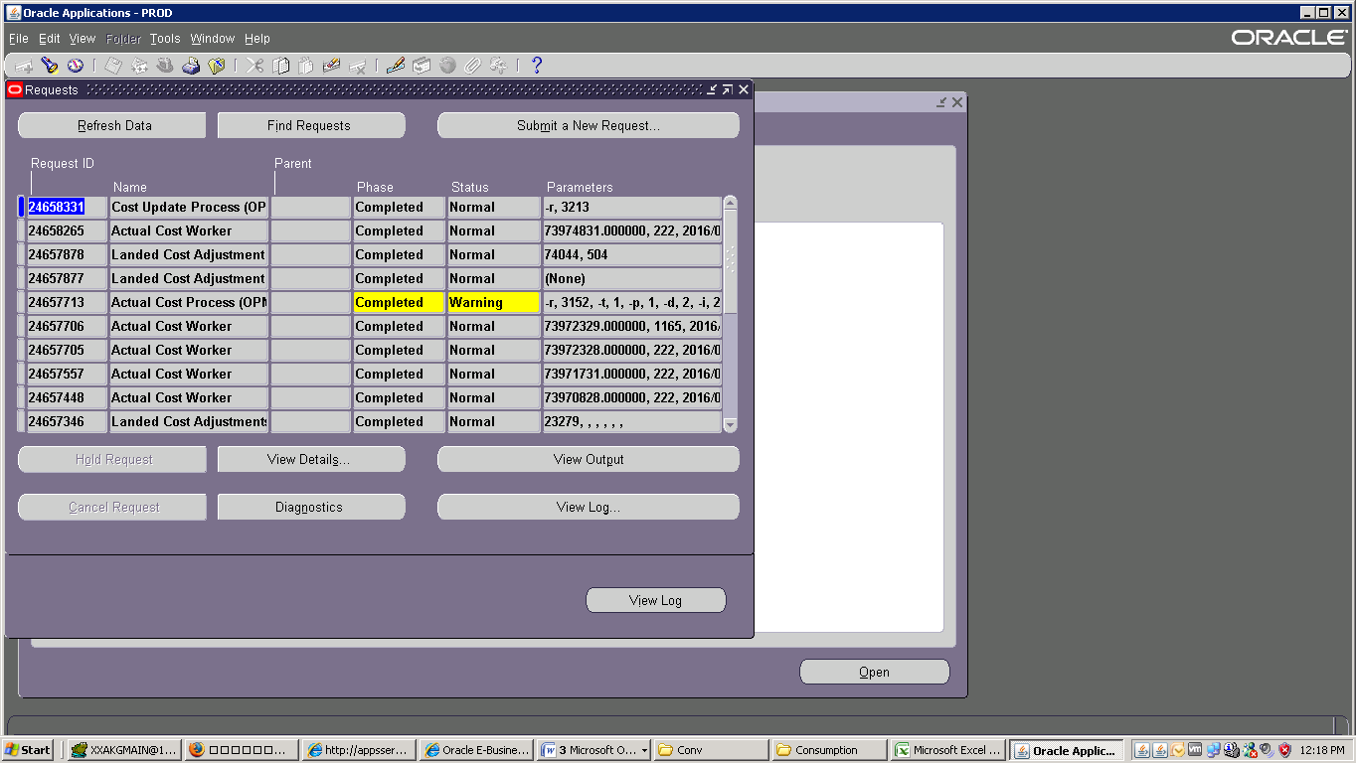

Check End time of Process Close :

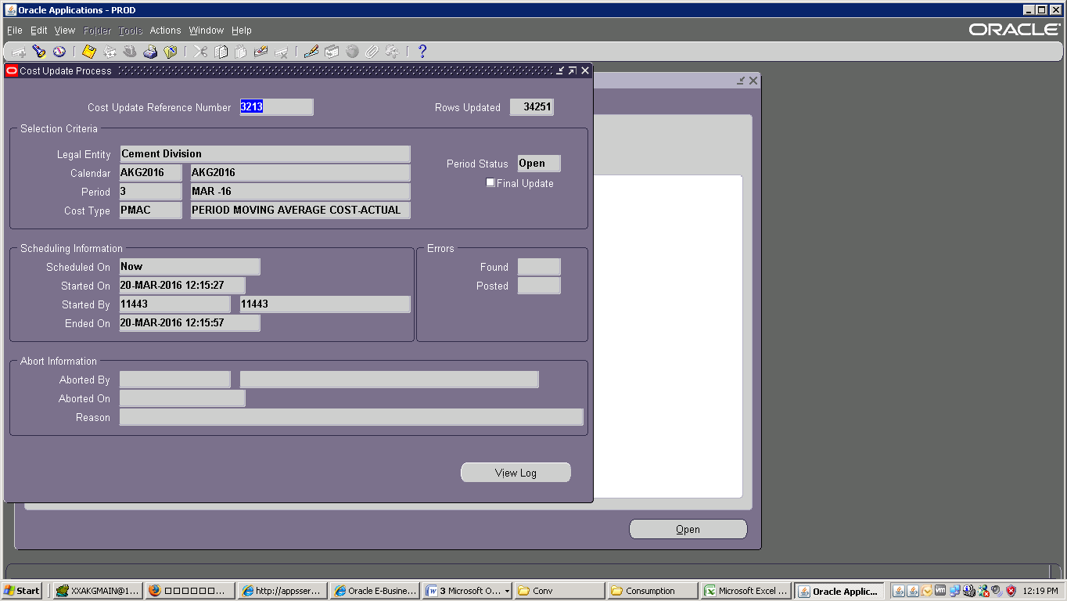

Select OPM Accounting Pre-Processor :

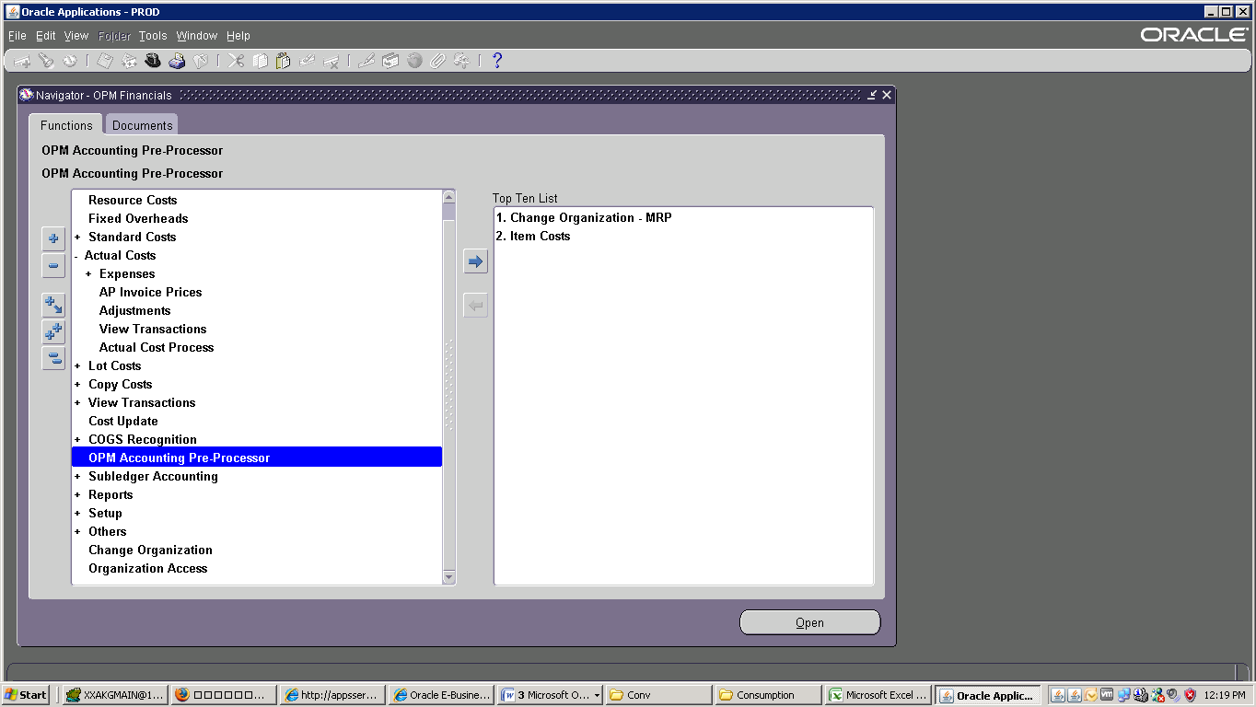

Parameters : Legal Entry : Cement Division🡪 Facial Year🡪 2016🡪 Period : 3 🡪Check 1st & 2nd Box

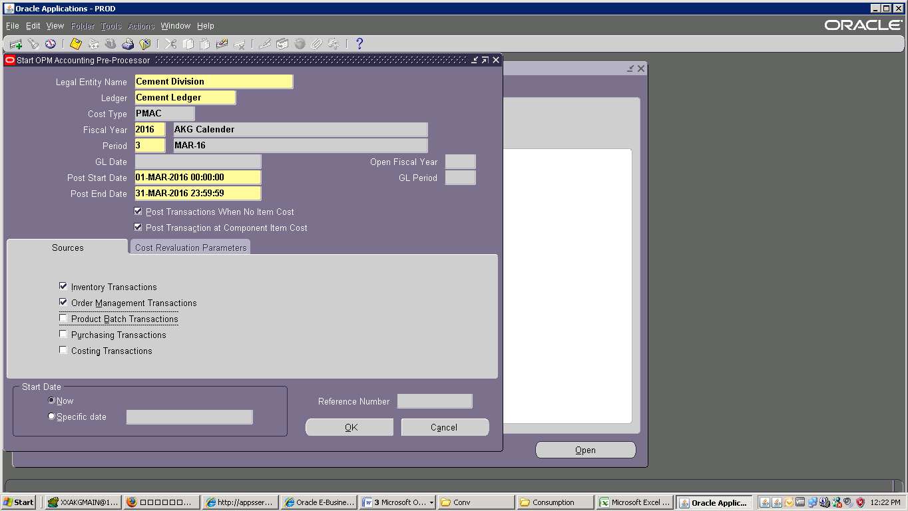

Click Ok and Submit than Refresh Data:

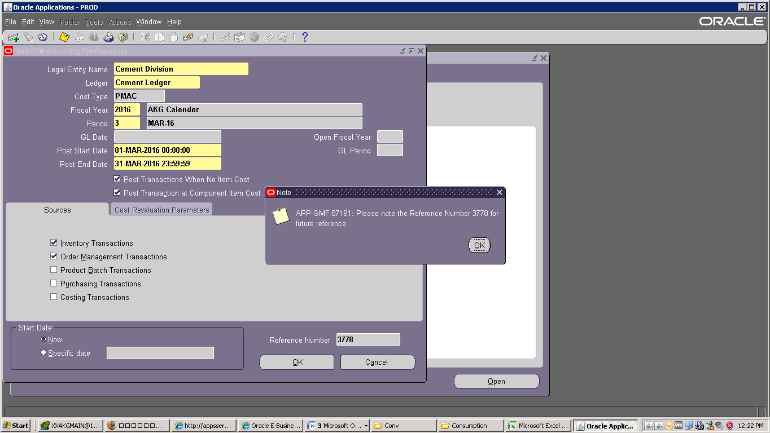

Click View 🡪 Request 🡪 Find :

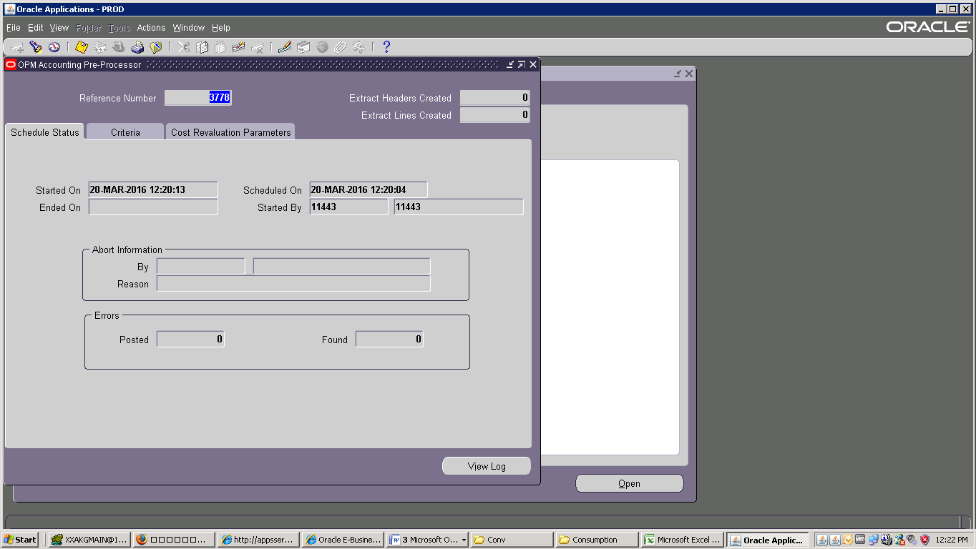

Click Submit than Refresh Data:

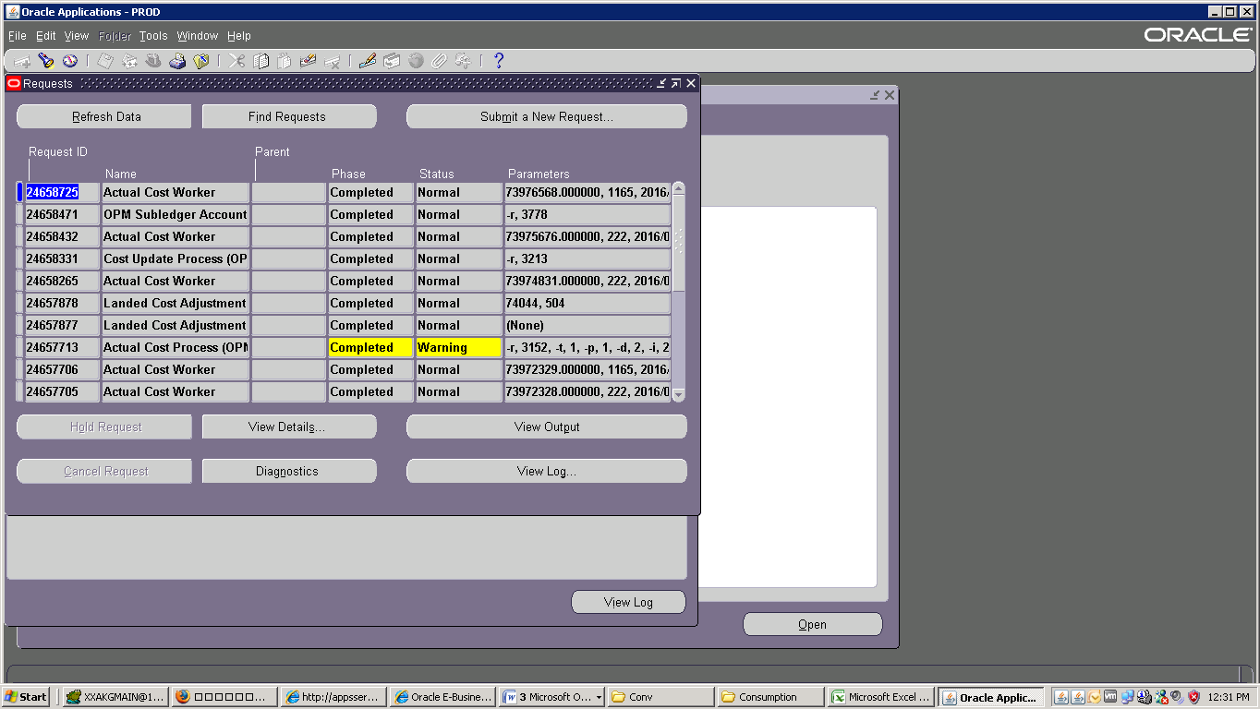

Check End time of Process Close :

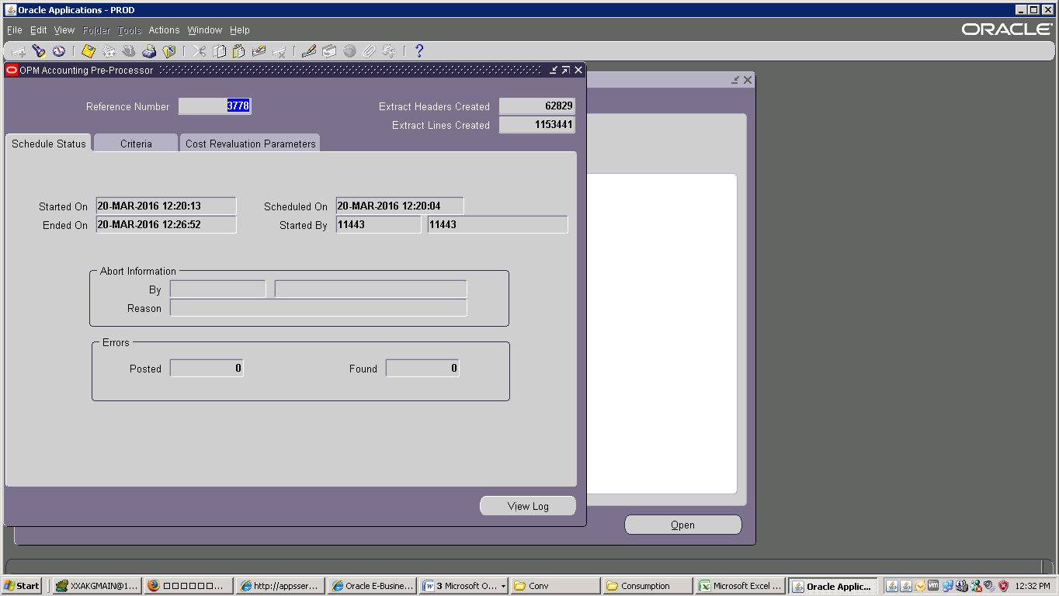

Parameters : Legal Entry : Cement Division🡪 Facial Year🡪 2016🡪 Period : 3 🡪Check 3rd Box

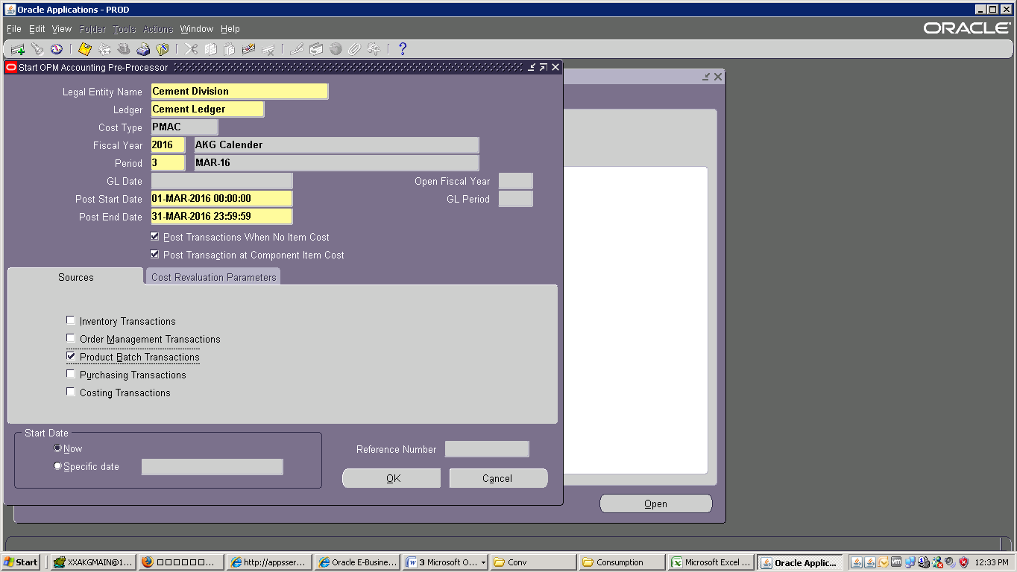

Click ok

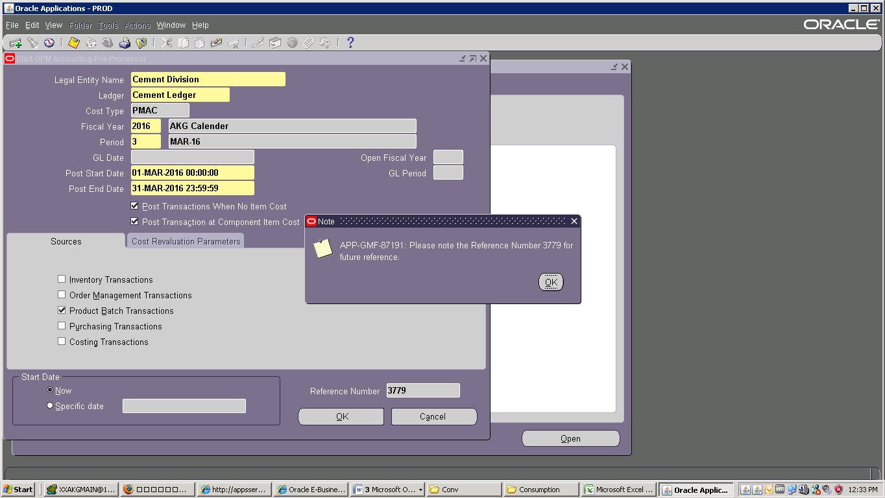

Click Submit than Refresh Data:

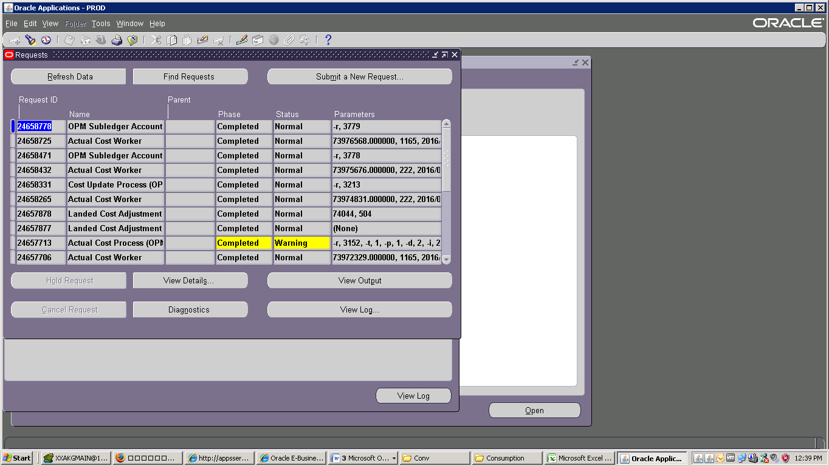

Check End time of Process Close :

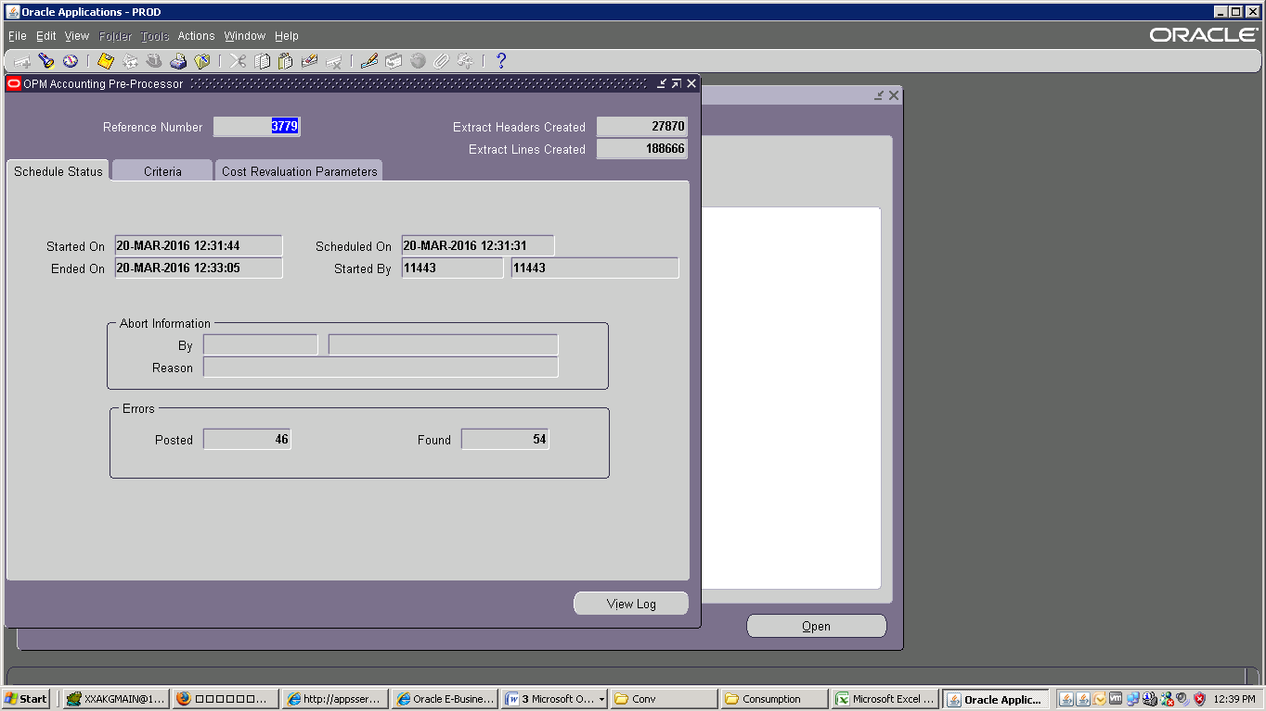

Parameters : Legal Entry : Cement Division🡪 Facial Year🡪2016🡪Period : 3 🡪Check 4th & 5th Box

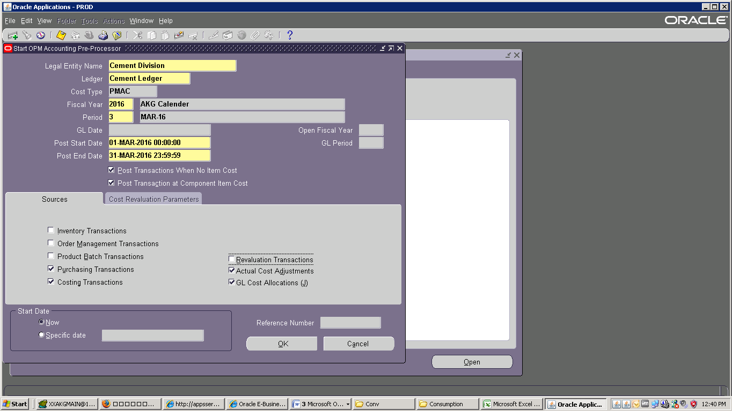

Click Ok

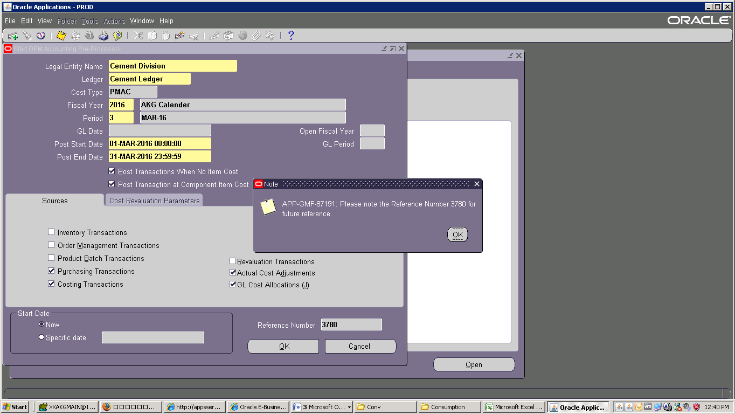

Click Submit than Refresh Data:

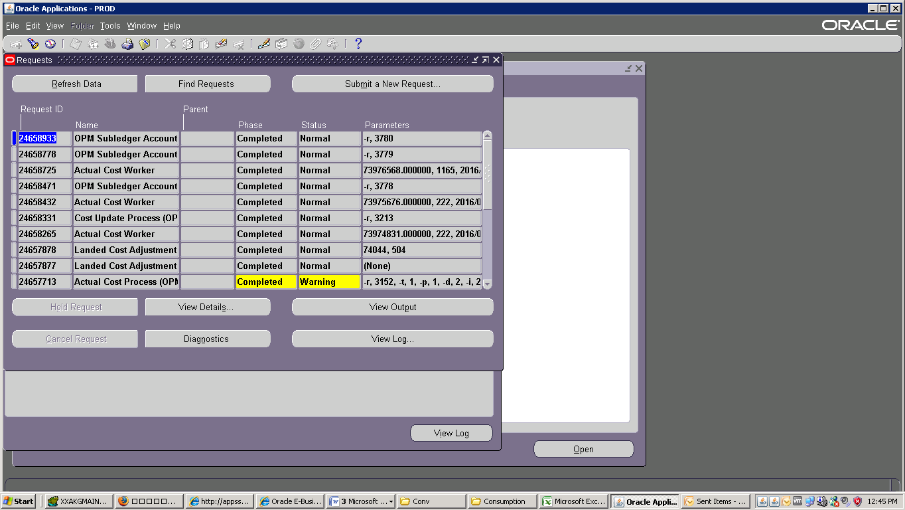

Check End time of Process Close :

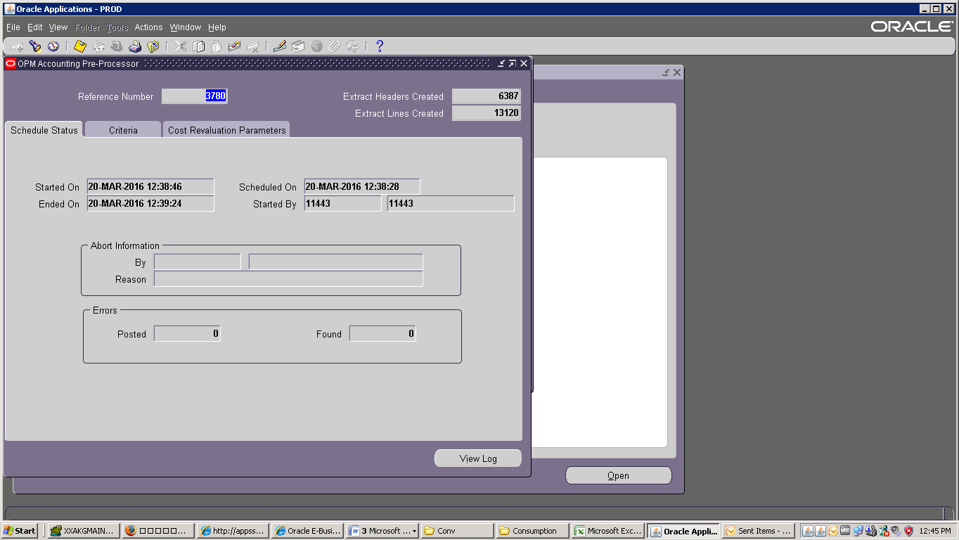

Veiw 🡪 Requeist 🡪 Create Account 1st 🡪 submit 🡪 No 🡪 Find

